**KNN**

**Example- Model for Zoo classification**

**Proportion of zoo**

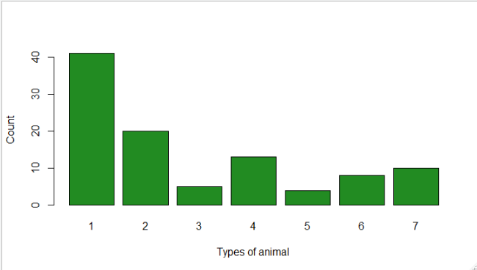

**1 2 3 4 5 6 7**

**41 20 5 13 4 8 10**

**From the above plot, out of 7 animals type 1 is highest amongst all.**

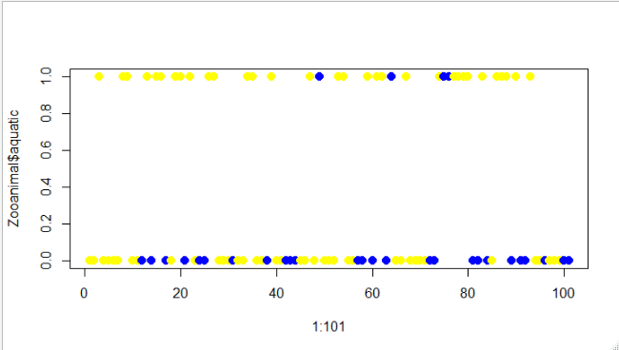

Upper blue dotted animals are Haired as well as aquatic and yellows are aquatic but not haired

Lower blue colored animals are non-haired and non-aquatic and yellows are non-aquatic but haired.

**Model Prediction**

**Model 1 🡺 Using caret and K = 3**

**1 2 3 4 5 6 7**

**1 10 0 0 0 0 0 0**

**2 0 7 0 0 0 0 0**

**3 0 0 0 1 1 0 0**

**4 0 0 0 5 0 0 0**

**5 0 0 0 0 1 0 0**

**6 0 0 0 0 0 3 0**

**7 0 0 0 0 0 1 1**

**Accuracy 🡺 0.9**

**Model 🡺 K= All odds from 1 to 50**

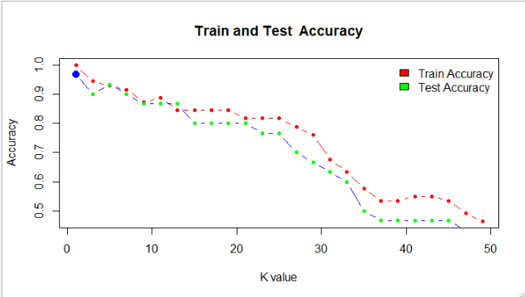

**From the above plot , for k=1we are getting highest test accuracy .**

**Final Model 🡺 K= 1**

**zoomodel**

**1 2 3 4 5 6 7**

**1 10 0 0 0 0 0 0**

**2 0 7 0 0 0 0 0**

**3 0 0 2 0 0 0 0**

**4 0 0 0 5 0 0 0**

**5 0 0 0 0 1 0 0**

**6 0 0 0 0 0 3 0**

**7 0 0 1 0 0 0 1**

**Accuracy 🡺 0.9666667**

**From the above prediction model, k=1 is our final model with best accuracy of 96.667% and only one type of animal 7 is mis-classified as**

**type 3.**